Jenkins CI/CD Pipeline

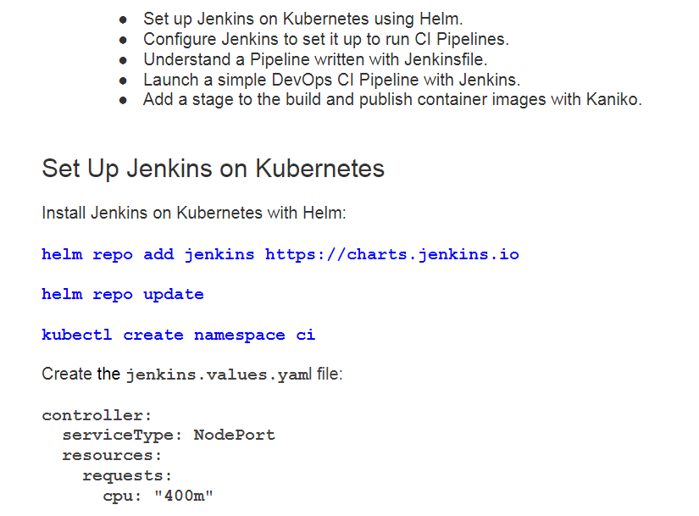

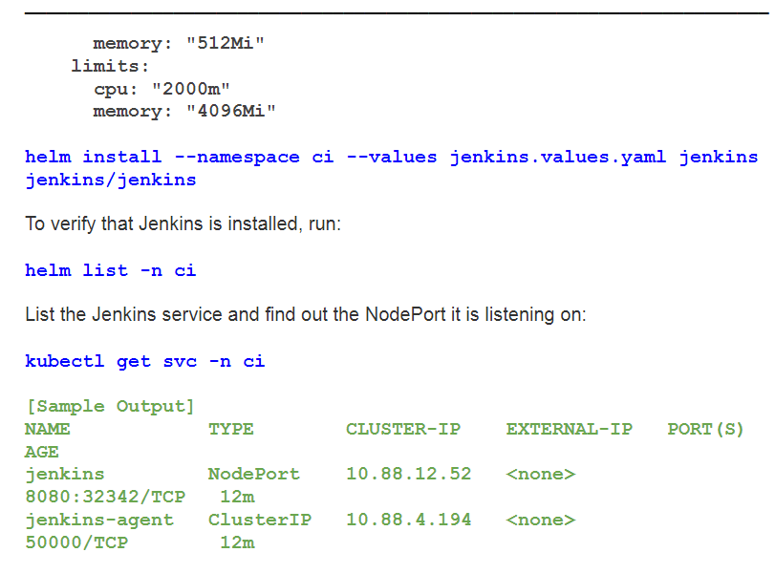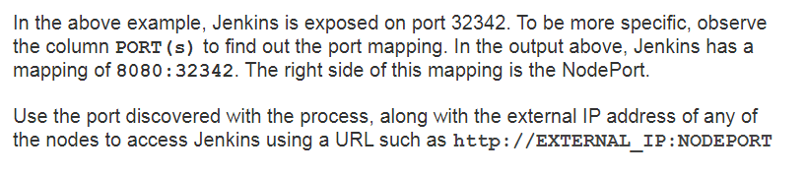kubectl exec --namespace ci -it svc/jenkins -c jenkins --

/bin/cat /run/secrets/chart-admin-password && echo

Use this password and login as the

admin

user.

______________________________________________________________________

Copyright, The Linux Foundation 2021. All rights reserved.

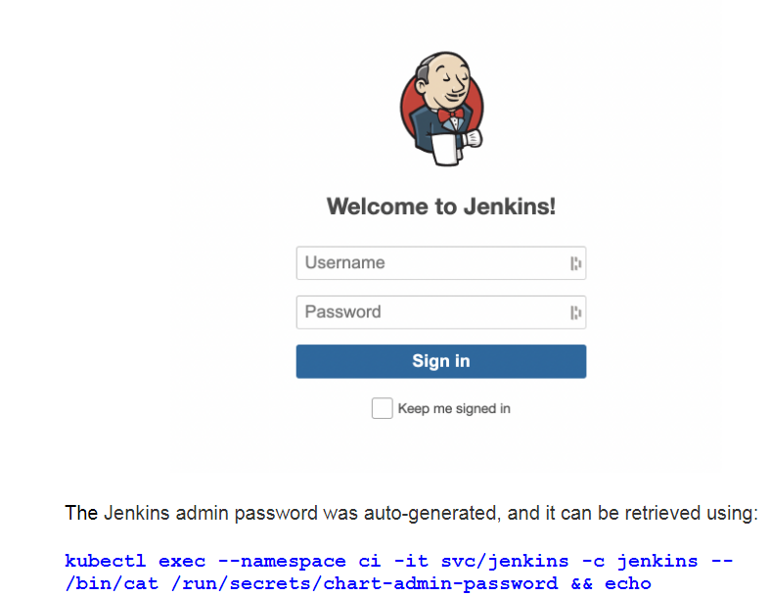

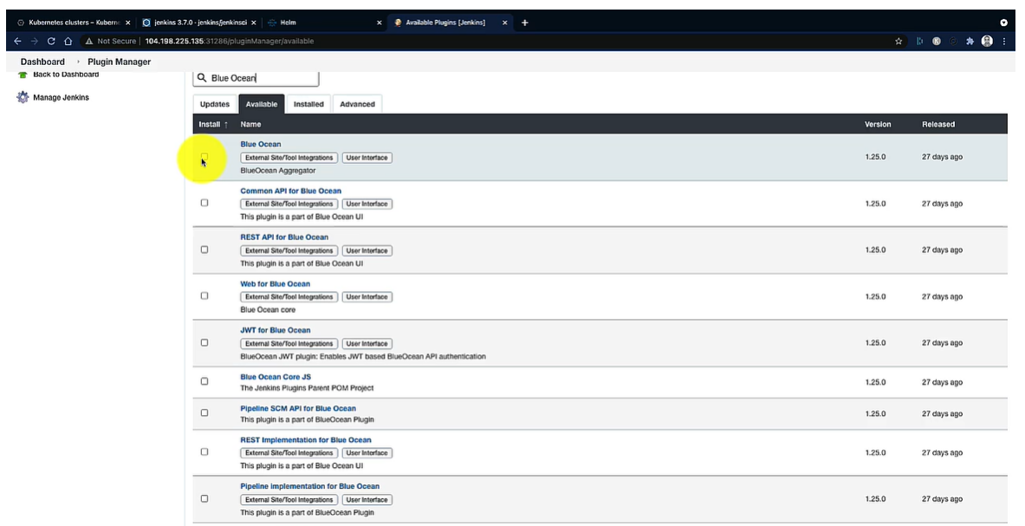

Configuration as code jenkins

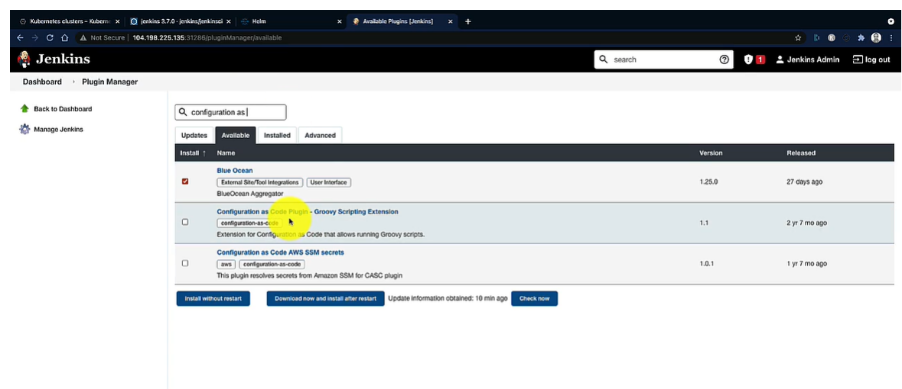

Jenkins Password Set up : kubectl exec --namespace ci -it svc/jenkins -c jenkins -- /bin/cat /run/secrets/additional/chart-admin-password && echo

Uopw4fUoiZTjMqavECKm2w

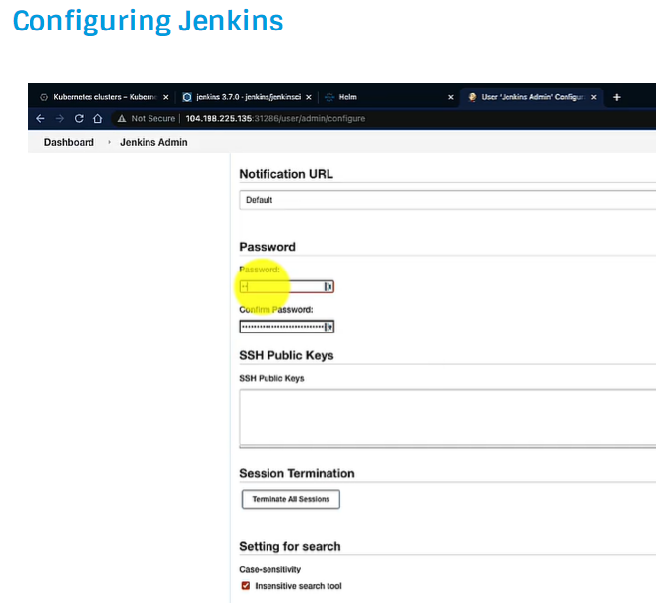

Scripted Pipeline

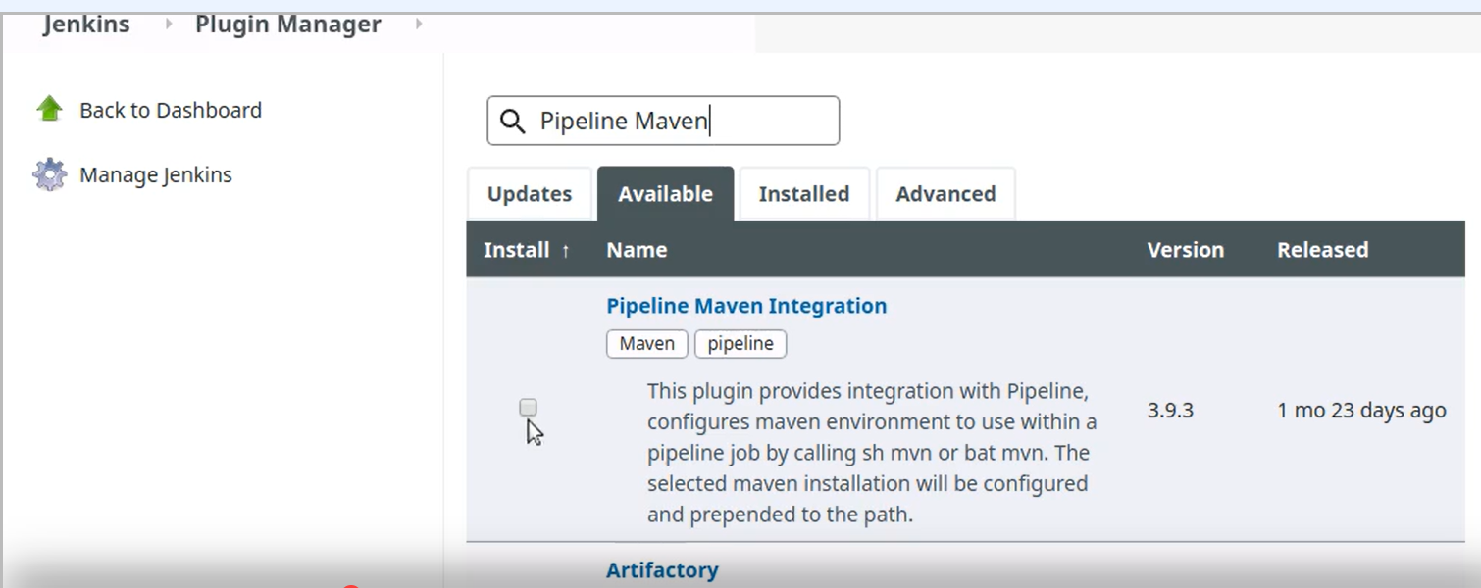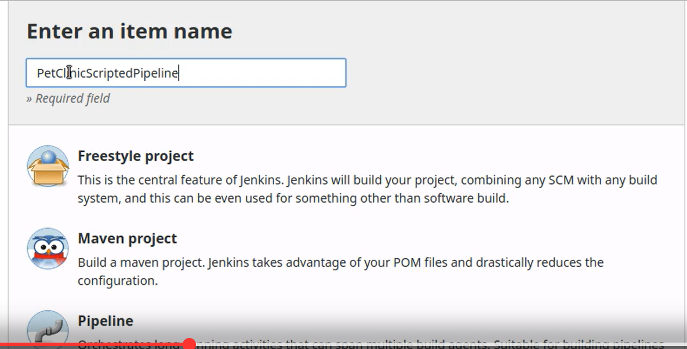

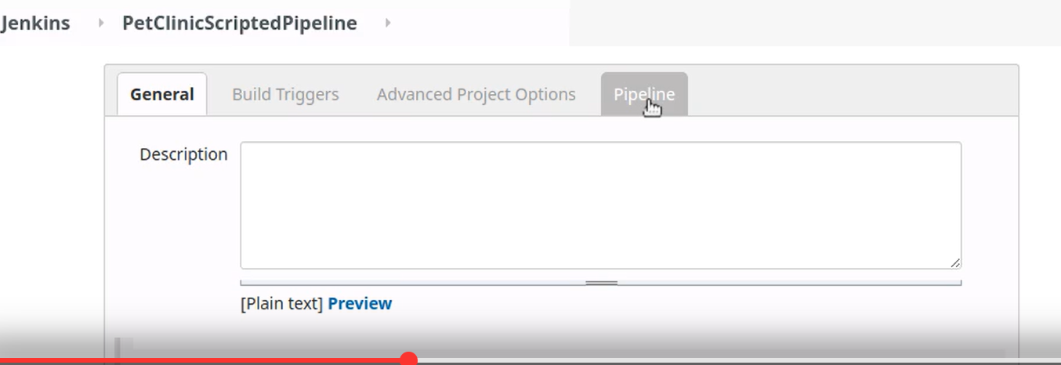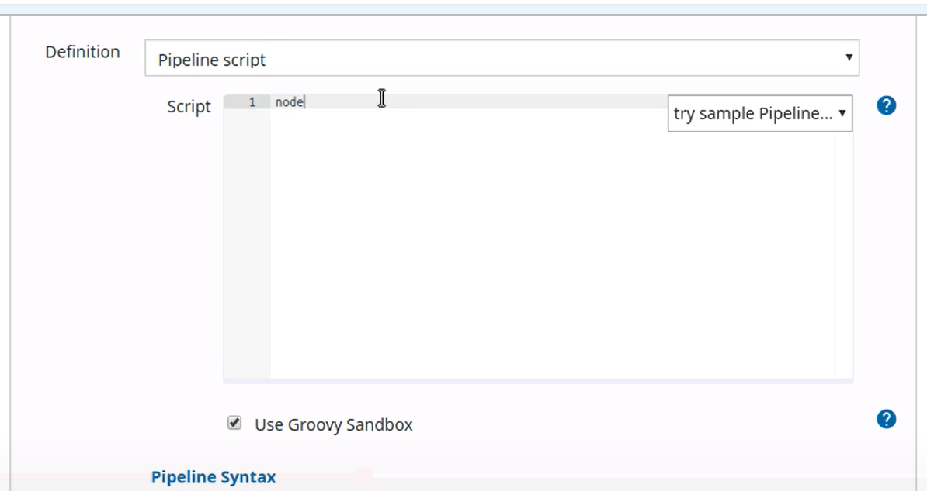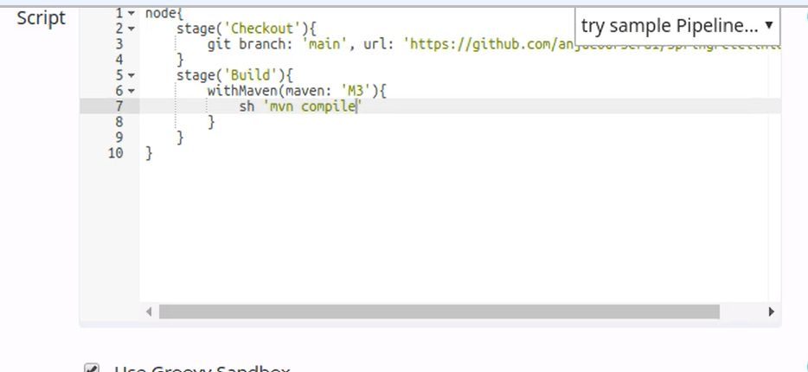

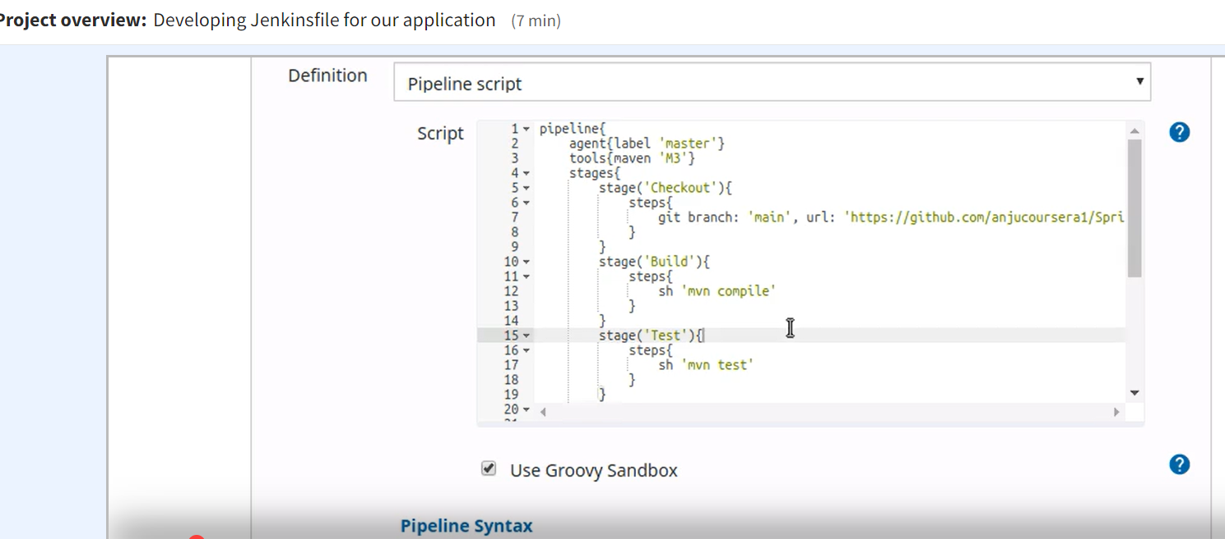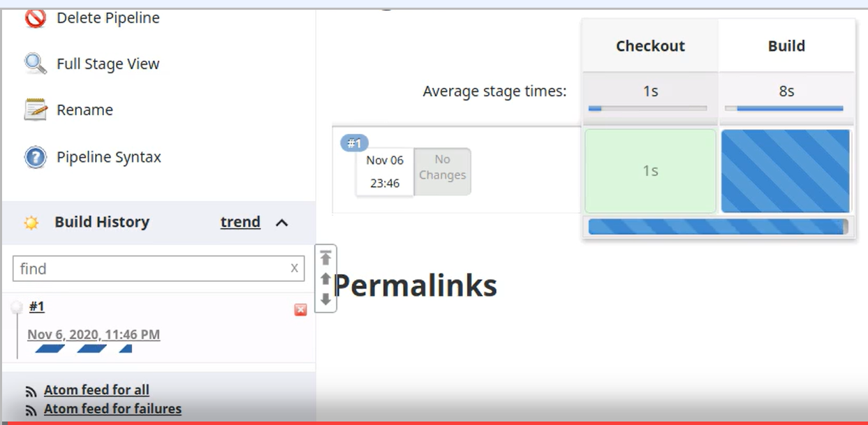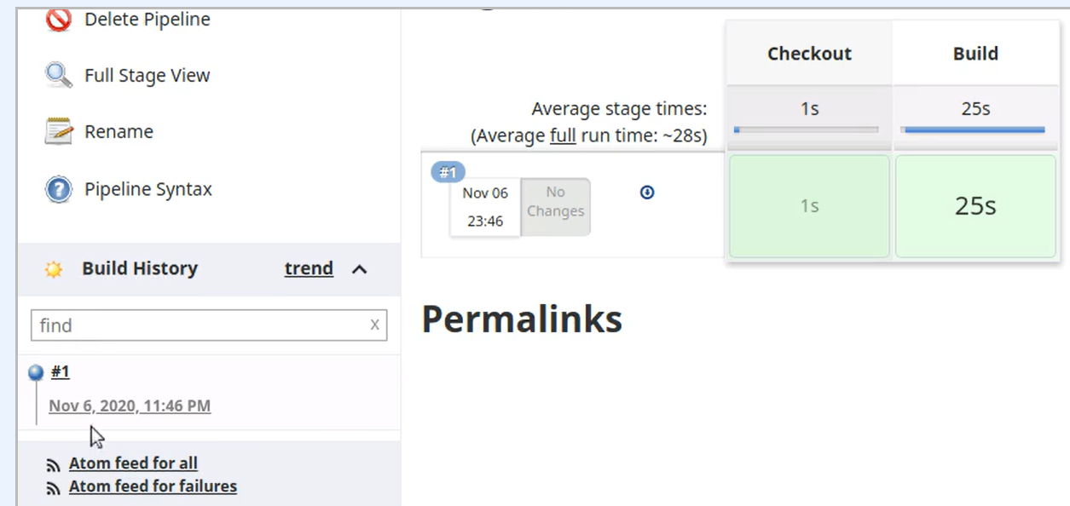

Scripted Pipeline

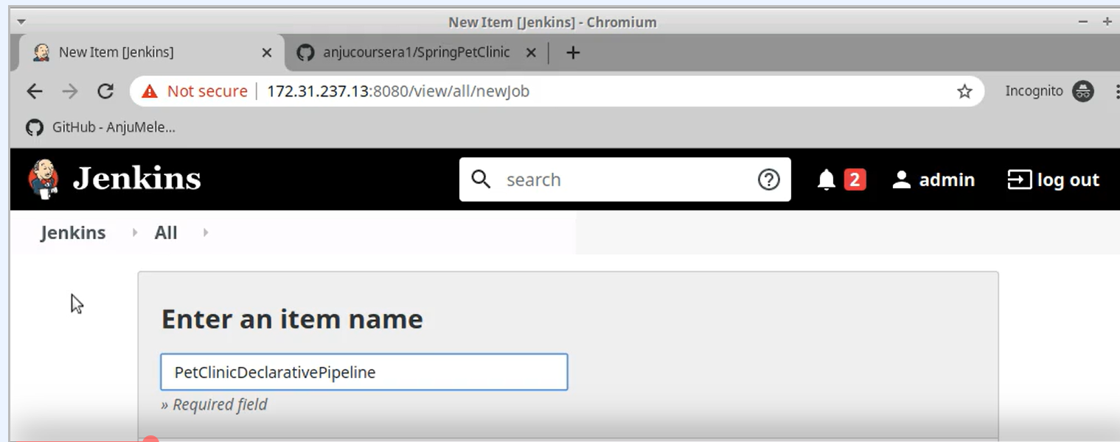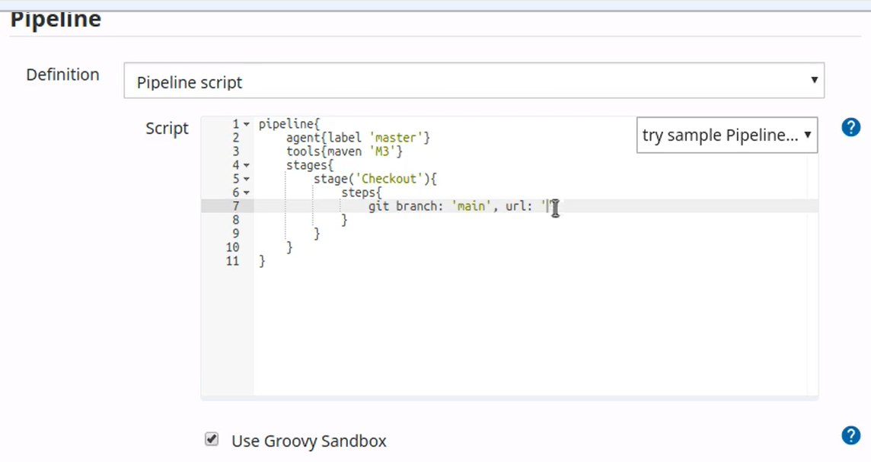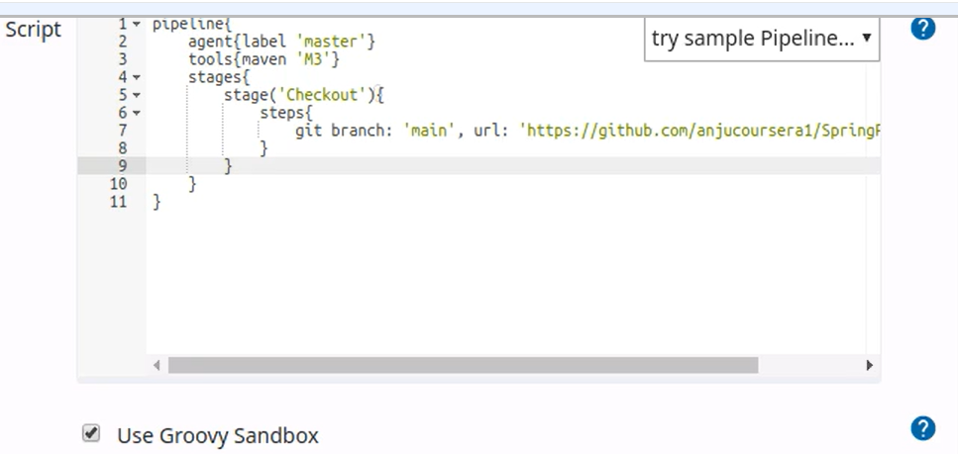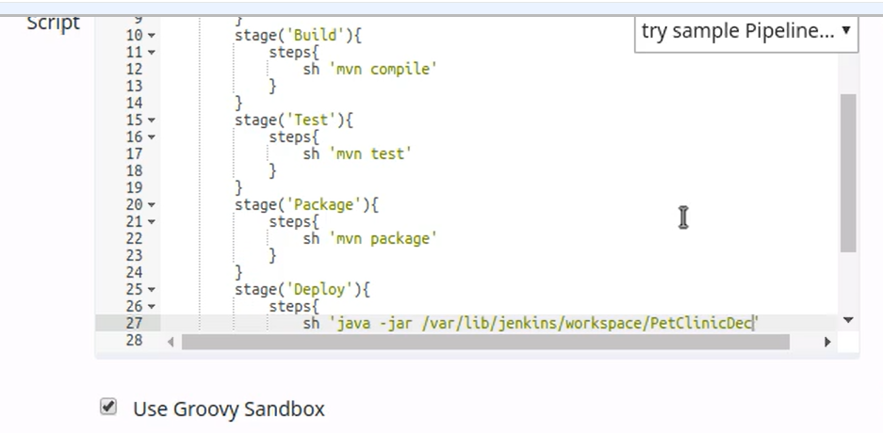

Declarative Pipeline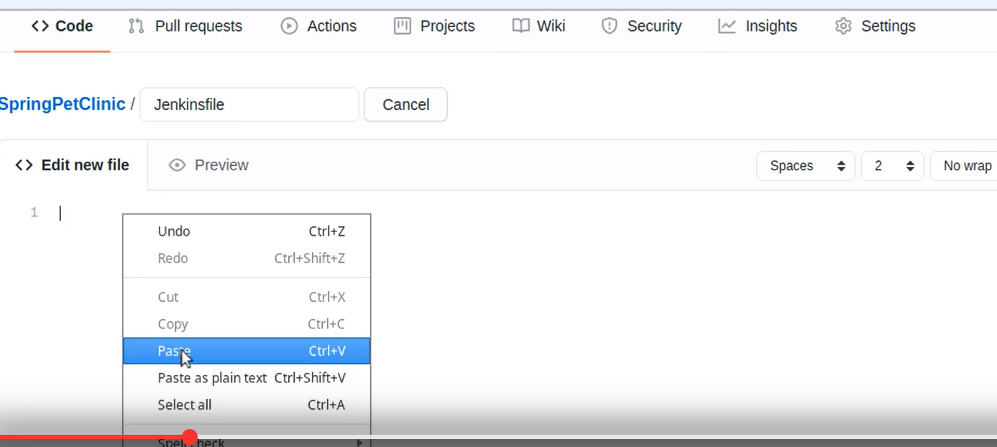

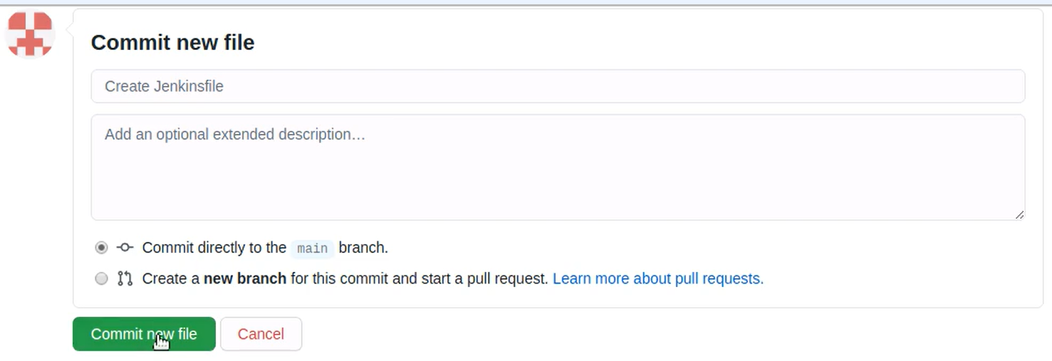

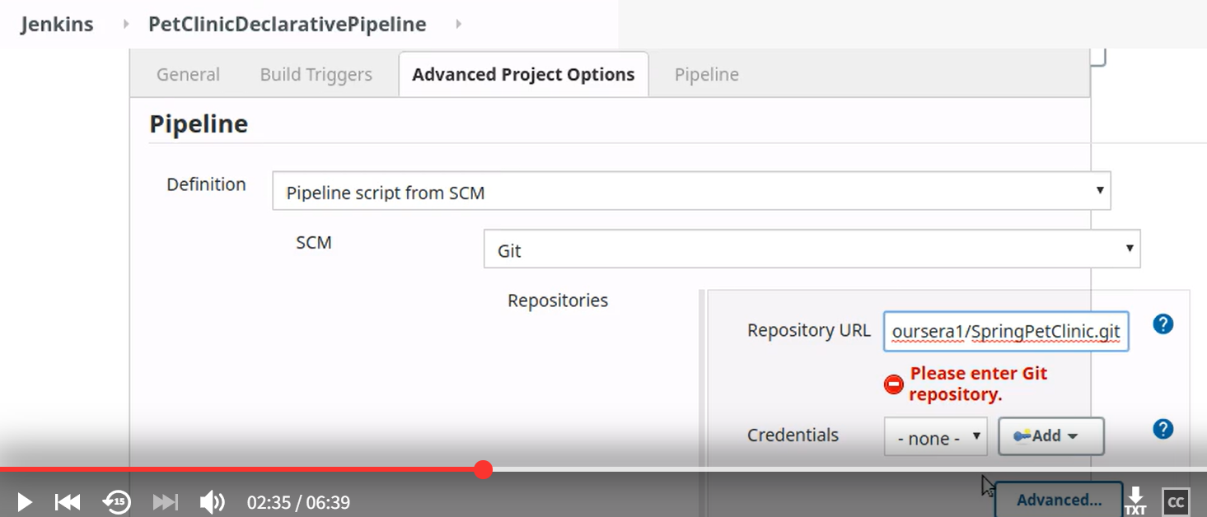

Modify the branch accordingly

